CREDIT CARD FRAUD RISK ANALYSIS- EDA- POWER BI

PROBLEM STATEMENT:

In today’s Power BI project, we are working on an exciting credit card fraud risk analysis. We will be exploring suspicious transactions, uncovering fraud patterns, and using dynamic dashboards to make data-driven decisions.

Fraud prevention and detection help identify and stop fraudulent activities before they escalate.

Fraud rate measures the percentage of transactions flagged as fraudulent out of all transactions. Fraudulent transactions show the total number of transactions identified as fraud. Critical risk transactions are high-risk transactions that need immediate attention

KPIs tracked-

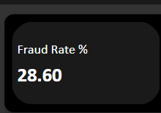The overall fraud rate % which is 28.6%

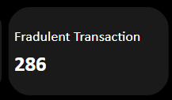 the number of fraudulent transactions

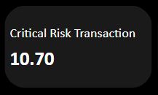the transaction that labelled as critical risk basis

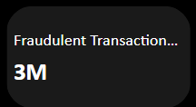total amount of fraud

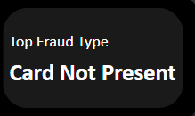

This is the transaction that happened via online platform without any physical card present. So that was the top fraud type.

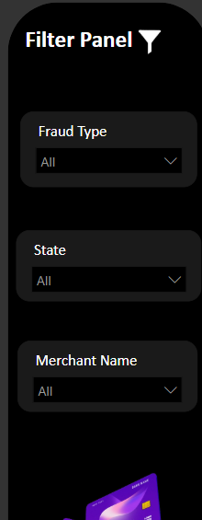next we have the filter panel, to select the type of frauds, select diff state and merchant type.

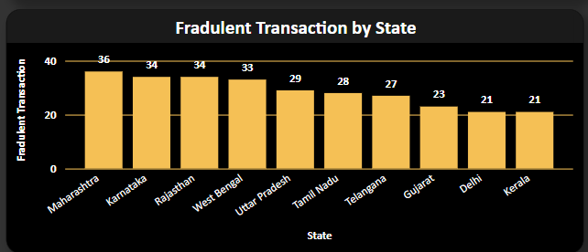 this represents state vs fraudulent transactions. Highest is in Maharashtra and least in Kerala.

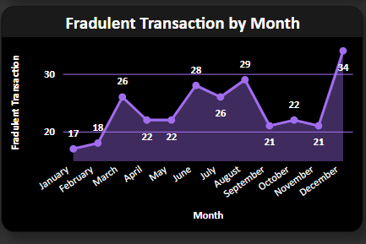this represents the frauds by months, December we see the highest transaction occurred, also in June and august there was peaks.

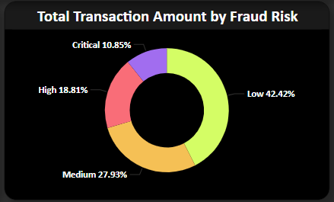the total transactional amount by fraud risk, low risk will show chances of fraud is less and people will trust more and put/ send their money. Lower the fraud risk, larger is the transaction amount.

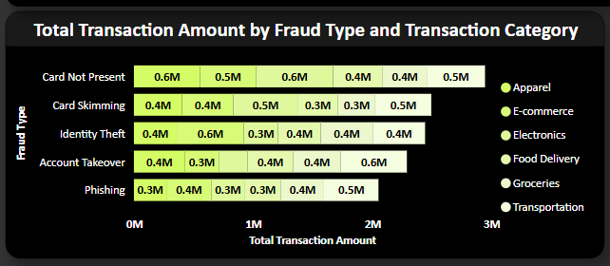diff kinds of fraud that has occurred, card skimming- skimmer is a device used to steal card information from where the card is swiped, highest in the apparel category, then e-commerce, electronics and so on. Identity theft- where the person information is stolen, and do transaction that is illegal. Likewise, in diff category the fraud happened is seen, the type of fraud and the amount which was stolen.